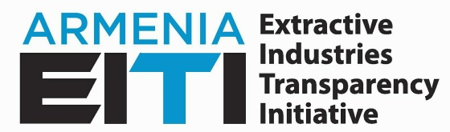
EITI NATIONAL PRIORITIES OF ARMENIA FOR 2019-2020
- Ensuring awareness about the mining sector

- Increasing the mining sector transparency and accountability, outspread of transparency and accountability standard through the expansion of the scope of EITI Armenia

- Enhancing the culture of responsible mining through application of the best international practices, and based on legal regulations

- Enhancing competitive investment environment for responsible investors

- Institutional capacity development of sector beneficiaries, strengthening the culture of systematic data disclosure in the sector

